**SmartVA Auto Analyse Version 2.15**

**User Guide**

Table of Contents

Introduction 3

Pre-requisites 3

Installation 3

Download the file 3

Run setup 3

Configuration File – Configuring for your environment 8

Opening the File 8

Settings 8

Emulator Install and Configuration 12

Installing Droid4X 12

Installing ODK Collect to Emulator 13

Installing the VA Form to the Emulator 14

Configure Root Mode 14

Tablet Configuration 20

Developer Mode 20

Running for the first time – USB connected device 21

Program Outputs – What does it do 22

Screen Output 22

File Outputs 23

Archive Folder 23

Results.csv file 23

Log Files 24

log.txt 24

adblog.txt 24

BriefcaseOutput.txt 24

TariffOutput.txt 24

SmartVA Auto Analyse User Guide

## Introduction

This program has been designed to allow the Cause of Death (CoD) to be determined automatically, once an entry or entries have been completed on an Android tablet using the ODK Collect application. It utilises ODK Briefcase and the SmartVA application to do this.

## Pre-requisites

For the successful running of auto-analyse, there are a number of pre-requisites that must be met.

* Windows 7 or newer operating system (Mac not supported)
* Windows Powershell 2.0 or greater must be installed on your system. This should already come installed with Windows, however it is noted here for completeness should you experience any issues with running the program.
* Java JRE is required to run the ODK Briefcase component. If this is not installed then you will be notified when you run the program for the first time. To install the latest version of Java JRE, head to <https://www.java.com/en/download/> and install this.

## Installation

### Download the file

To begin, download the setup file from the link below:

* <https://cloud.mdhs.unimelb.edu.au/index.php/s/AcvrIYIbhVv7CZM>

### Run setup

Once the download has completed, close any open programs and navigate to the download location (***do not run the file directly from your browser***). Right-Click on the installer file and select ‘Run as administrator’.

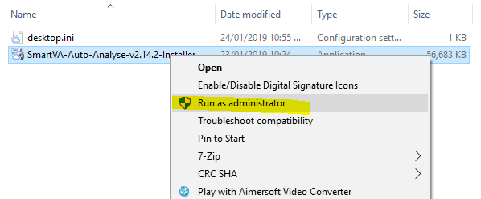

Click **Next** to continue

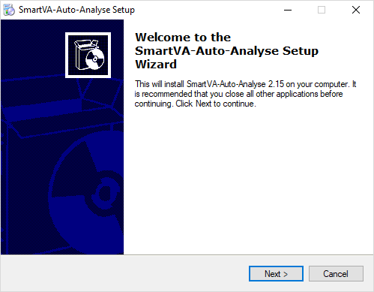

Read the License Agreement and click on **I accept the agreement** if you agree to the license and wish to continue installing. Click **Next**.

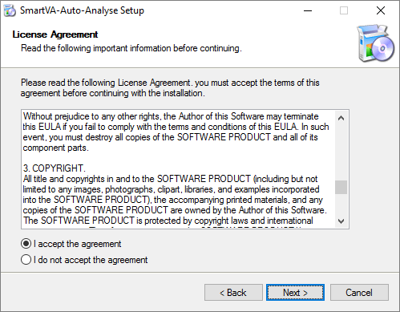

The installer with now install the program files, setup your desktop icon and check for an existing version of C:\SmartVA

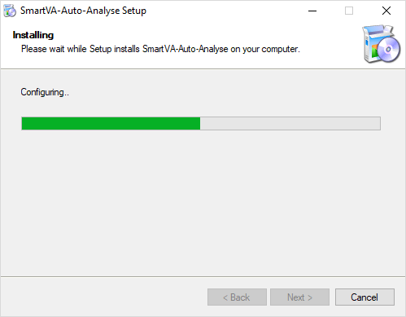

If, during configuration, an existing **C:\SmartVA** folder is detected then you will be advised that this will be renamed. This is due to differences in the versions of software in use and is to ensure that old data is kept safe. Click **OK**.

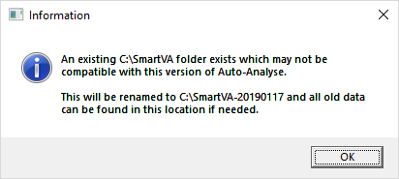

**Important:** If the installer is unable to rename this folder then you will be advised there was an issue. This folder should be renamed manually to ensure that data does not become corrupted when using the new version.

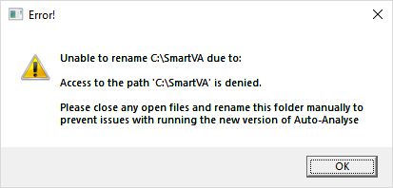

Once this has been performed then the Android Debug Bridge install will commence.

The Android Debug Bridge (required to communicate with the Tablet) installer will launch. Answer ‘**Y**’ to each question to have the ADB component and driver installed. If you have previously installed this, then Answer ‘**N**’ to each question.

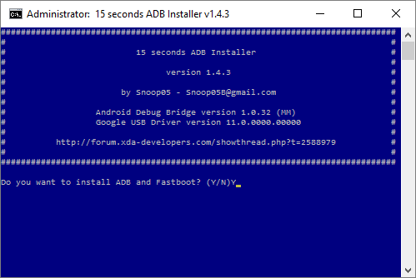

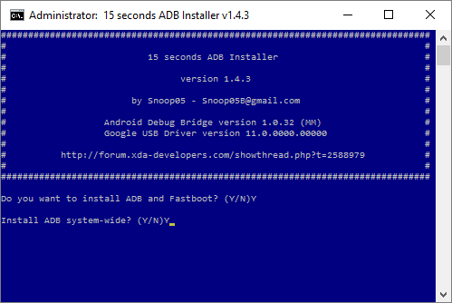

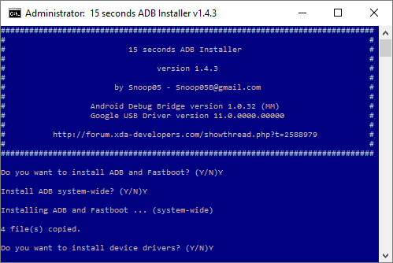

The device driver installation wizard will now run. Click **Next.**

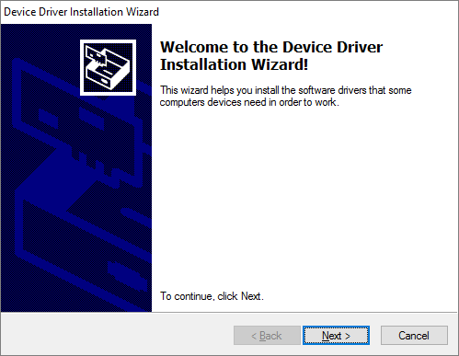

You may see a warning like the one below. Click **Install**.

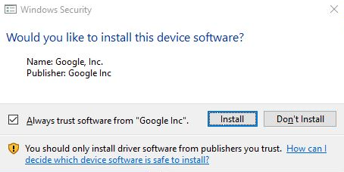

Click **Finish** to complete the ADB Driver installation and return to the program installation

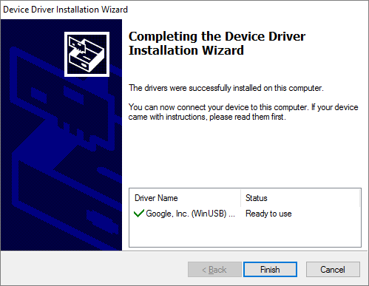

Finish the program installation by clicking **Finish**. This will reboot your computer and finalise the installation of drivers and other components.

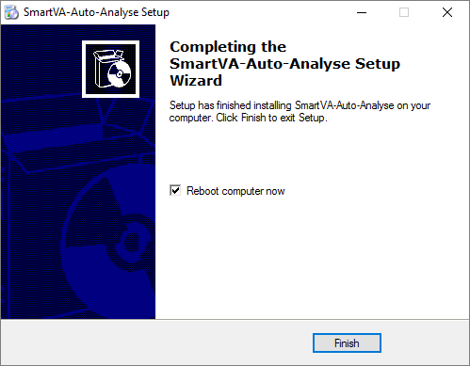

## Configuration File – Configuring for your environment

### Opening the File

This program uses a configuration file to allow particular settings to be changed. These will need to be reviewed prior to running for the first time, and set appropriately for your implementation. Any changes will be reflected when the program is next run. To view and edit this file, you need to open the file in Notepad. To do this, perform the following:

* Open Windows Explorer
* Navigate to **C:\University of Melbourne\SmartVA-Auto-Analyse.** Open the configuration file ‘**config.txt**’.

The file should now be open for editing and look similar to the below:

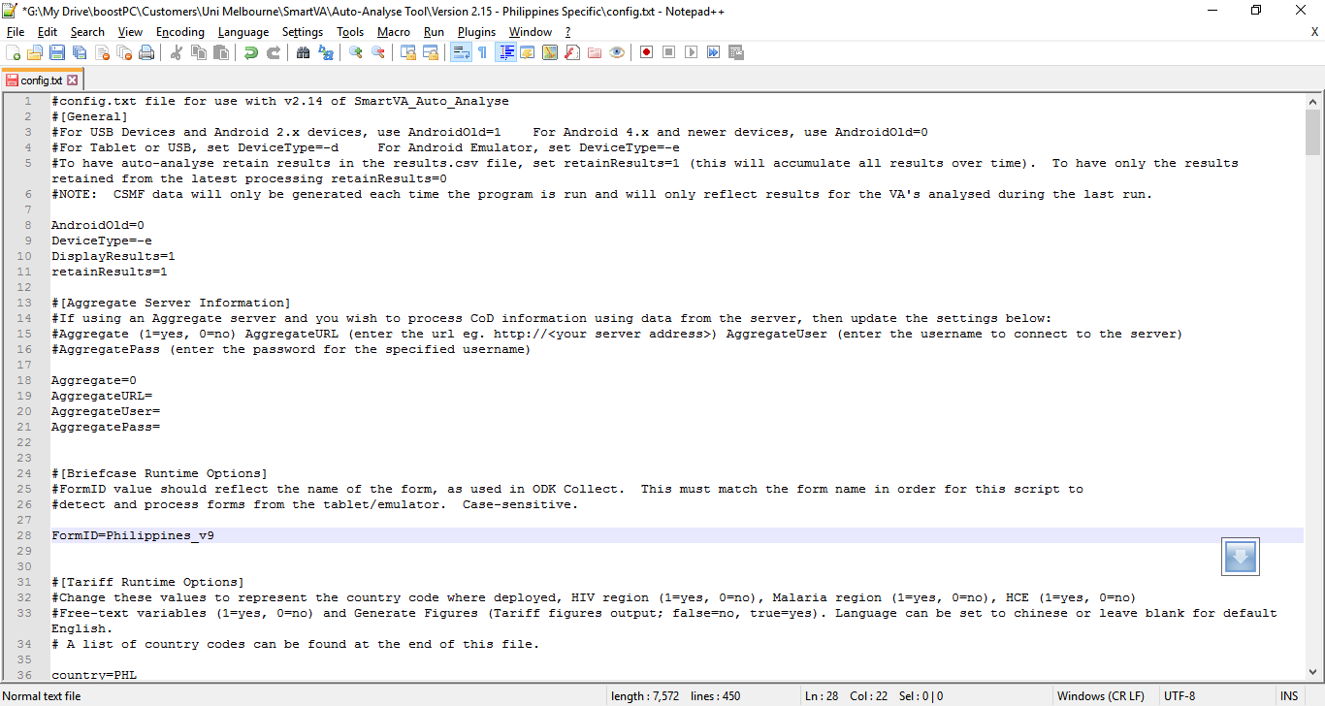

### Settings

There are a number of settings in this file, each grouped under specific headings. Each of the headings and configuration options are explained below. Note that 0=Off/No and 1=On/Yes for applicable settings.

**[General]:** This is the general section that is used to define general program settings

**AndroidOld:** If you have an older Android device running version 2.x, or if you are accessing data stored on a USB drive, then set this value to ‘1’. This will prevent the program from trying to access the device via ADB and will use the USB Mass Storage method of obtain files. If this setting is set to ‘0’, then the program will assume a newer Android device is connected and will use the installed ADB drivers (with tablet in Developer Mode) to pull data directly from the tablet.

Default value: 0

**DeviceType:** This setting allows you to specify if you are running a physical device or an emulator (such as MEmu or Bluestacks). For a physical device, leave this setting as ‘-d’. If using an emulator, set this to ‘-e’. Note: the AndroidOld setting should be set to ‘0’ for this to work.

Default value: -e

**DisplayResults:** This setting defines whether results will be displayed to screen. Setting this to ‘0’ will prevent display to screen and results will be logged in the archive ‘results.csv’ file only. Setting this to ‘1’ will display results and prompt for a Physician Cause of Death to be entered for each record processed.

Default value: 1

**retainResults:** This setting changes the way that results are stored in the archive ‘results.csv’ file. Setting this to ‘0’ will mean that only results from the current run will be retained. Setting this to ‘1’ will allow the accumulation of all results processed overtime to be stored/maintained.

Default value: 1

**[Aggregate Server Information]:** This section contains settings related to your aggregate server if used.

**Aggregate:** Set to ‘0’ if you are processing data from a tablet; Set to ‘1’ if you have an aggregate server that you wish to process data from.

Default value: 0

**AggregateURL:** The URL of your aggregate server should be entered here

Default value: <blank>

**AggregateUser:** A valid Aggregate Server username should be entered here

**Default value:** <blank>

**AggregatePass:** The password for the above-specified user should be entered here.

Default value: <blank>

**[Briefcase Runtime Options]**: This section is used to define the runtime options for ODK Briefcase.

**FormID:** The name of the form in use is required by ODK Briefcase in order to export the correct information. Once a form has been uploaded to an Android device for use with ODK Collect, the form name should also be updated here to allow the automated processing of any entries created. ***This setting is case-sensitive and needs to match the exact name of the form as seen in the device.***

Default value: Philippines_v9

**[Tariff Runtime Options]:** As with ODK Briefcase, the SmartVA-CLI application requires certain parameters in order to analyse and produce results. These parameters are set in this section.

**country:** A 3-letter abbreviation representing the country that the data originated from. Note that all valid country abbreviations are listed at the bottom of the configuration file for easy reference.

Default value: PHL

**hiv:** This setting is used to indicate if this is an HIV region. Set to ‘0’ for no, and ‘1’ for yes.

Default value: 0

**malaria:** The user must determine whether malaria is a possible cause of death in the population from which the VAs were collected. If this the box next to “Malaria region” is not selected, the Tariff Method will not assign malaria as a cause of death. Set to ‘0’ for no, and ‘1’ for yes.

Default value: 0

**hce:** This setting relates to Health care experience variables. The user should determine whether, as part of the survey, questions regarding the health care experience (HCE) of the deceased or his/her family are asked. If the setting for hce is set to ‘0’, these variables are not included in the analysis, and the software will use appropriate training data which are not enhanced with HCE variables.

Default value: 1.

**freetext:** If your data has an open response component and you would like this to be analysed by the Tariff Method, make sure this setting is set to ‘1’.

Default value: 1.

**figures:** This setting allows you to specify if Tariff figures are to be generated or not at run-time. As this requires more processing time and overheads, this is turned off by default. Set this value to ‘true’ to have figures generated, or ‘false’ to omit these figures when running the program.

Default value: false

**language:** This setting allows you to specify a supported language. Leaving this setting blank will default to English. Alternatively specify ‘chinese’ or ‘spanish’.

Default value: <blank> (English)

**[Locations]:** This section contains settings related to file locations for use with the program

**ProcessDir:** This is the ‘working directory’ for the program and is where the program will store many of the files used to process your results. Note that the results.csv output file and also all archived information will be stored in the Archive directory (see ArchiveDir setting below). This directory also contains the Tariff output files that you would usually find in the TariffFiles sub-folder. Note that these are cleared each time the program runs and only the predictions and csmf Tariff outputs are kept (stored in the archive folder also).

Default value: C:\SmartVA

**ArchiveDir:** This is the ‘archive directory’ for the program. This directory is used to store a copy of files found on your tablet or emulator after processing. If there are any errors with Tariff processing, the program will copy the tablet files to an ‘Errors’ subfolder which can then be reviewed at a later date. Any files copied to the Archive can also be used to process results manually, using ODK Briefcase and SmartVA software. If SmartVA-auto-analyse is successful in processing your Tablet files, a copy of these will be placed under the ‘Processed\Forms’ subfolder and ‘Processed\Instances’ subfolder. Only the latest version of any given form or instance is maintained in the archive to prevent duplicates of raw data, and to ensure any changes in VA data are captured in the archive (such as a form/VA that is edited AFTER having already run this program).

It is possible to set this value to either a drive location or a UNC path, and therefore can be used to store the Archive on a network drive or location that can then be backed up and retained overtime (recommended). If this Network location is used for all computers running this program, then their data will be aggregated into the archive, creating one full dataset with associated form(s). Refer to your IT support team to determine if this option is available.

Default value: C:\SmartVA

**[Tablet ODK Collect Directories]:** This section contains settings related to the ODK Collect application directory

**ODKDir:** This setting should reflect the name of the odk folder as used by ODK Collect on the device. The current version of ODK Collect uses the directory ‘**odk**’. Should the directory name change with future ODK Collect versions, this setting can be updated to ensure the program will continue to function correctly.

Default value: odk

**FormsDir/InstancesDir:**  FormsDir and InstancesDir are the directory names as they appear in the CollectFiles directory, contained within the ProcessDir as set above. These values should not need to be changed unless ODK Collect software changes the names of these default locations as part of future updates. Default values: FormsDir=forms, InstancesDir=instances

## Emulator Install and Configuration

This version of Auto-Analyse ships with optional emulator software (Droid4x) to allow the collection and processing of Verbal Autopsy’s on one device (Windows 7 – 10).

### Installing Droid4X

To install the emulator, close all open programs and open Window Explorer.

Navigate to **C:\University of Melbourne\SmartVA-Auto-Analyse**  and double-click the **Droid4xInstaller.exe** file.

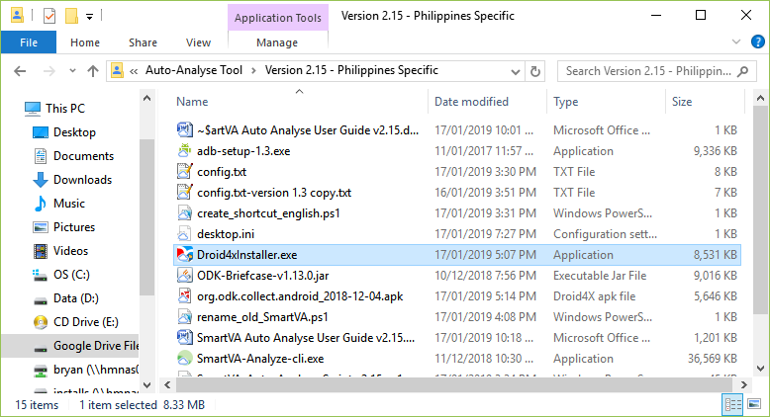

Once the installer loads, Click **Install**

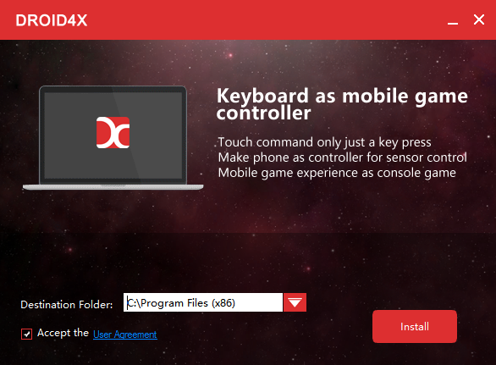

The installer will install the application

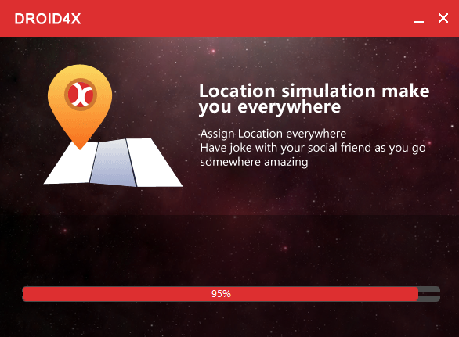

Once successfully installed click **Open**.

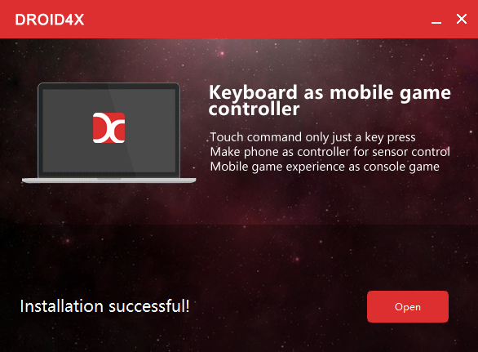

The emulator will load and, once complete, you will see the screen below. Click on the Home button.

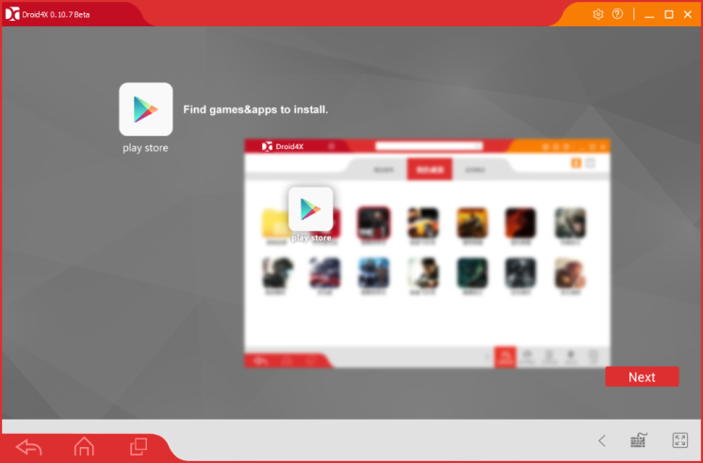

### Installing ODK Collect to Emulator

With the emulator open and running, navigate to **C:\University of Melbourne\SmartVA-Auto-Analyse**  and double-click the **odk-collect.apk** file. This will install ODK Collect automatically, ready for the next step (adding the Philippines VA form).

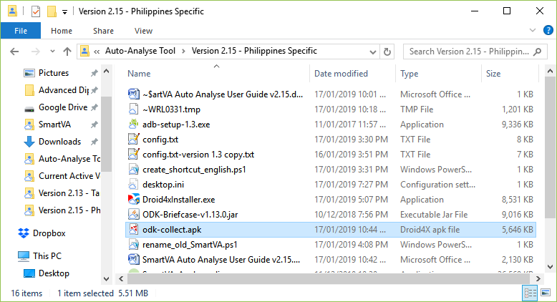

Once installed, you should see ODK Collect appear in the emulator as follows:

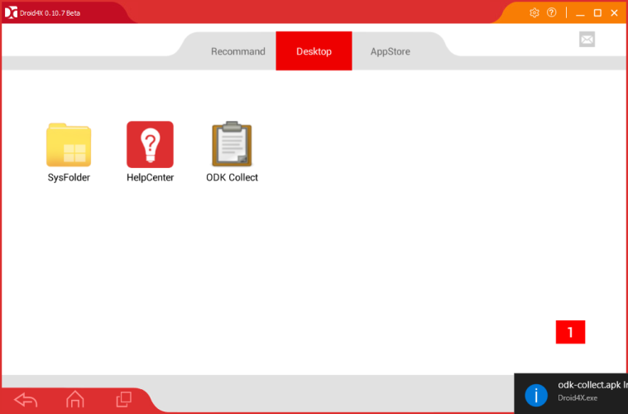

***Launch ODK Collect by clicking on it, to confirm it has installed correctly (this is also important for the steps that follow).***

### Installing the VA Form to the Emulator

To install the form for use with Verbal Autopsy, you will need to obtain a copy of the latest form file (Philippines_v9.xml at time of writing) and place it on your desktop in preparation for the next steps.

#### Configure Root Mode

In order to copy the form file, Root Access Mode should be enabled.

From the emulator home page, click on SysFolder:

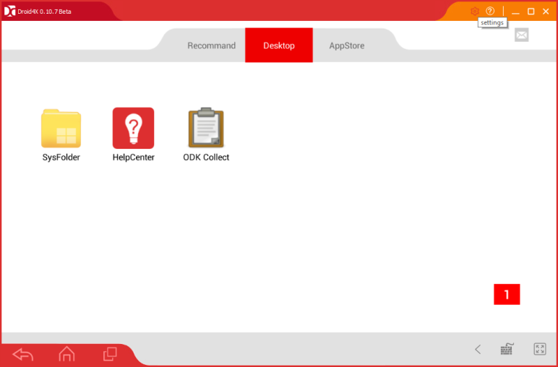

Click on File Manager

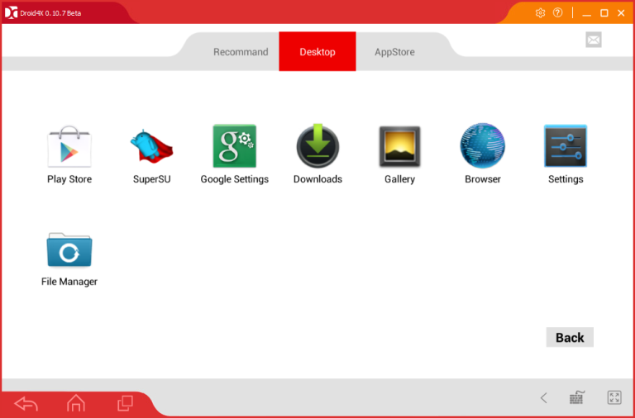

Click on the three dots and click **Settings**.

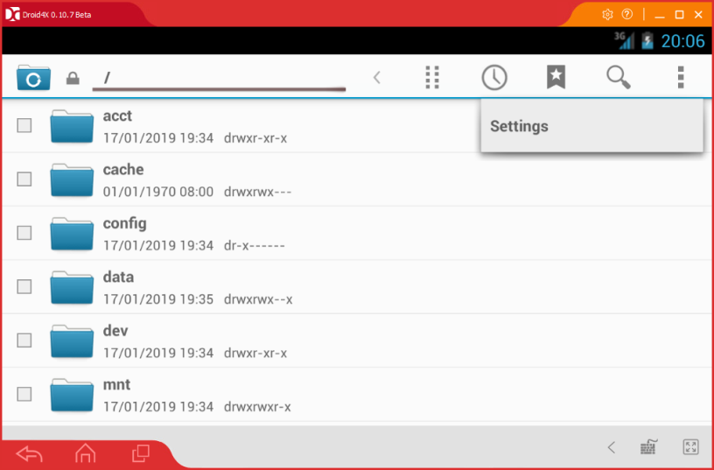

Click on General Settings, scroll down and select Access Mode.

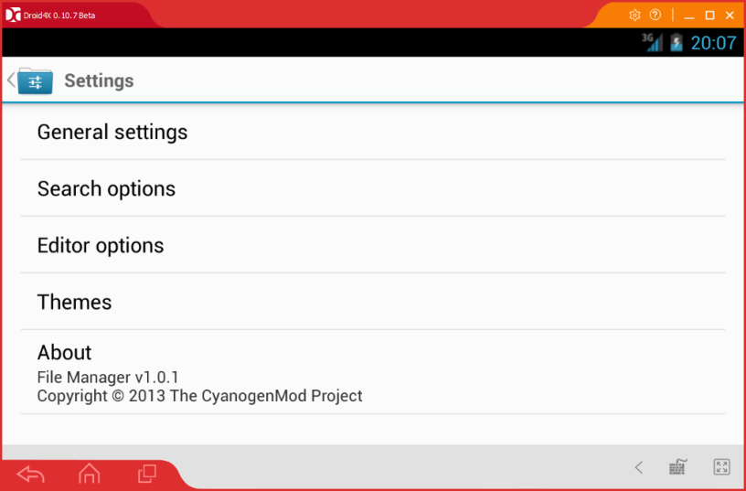

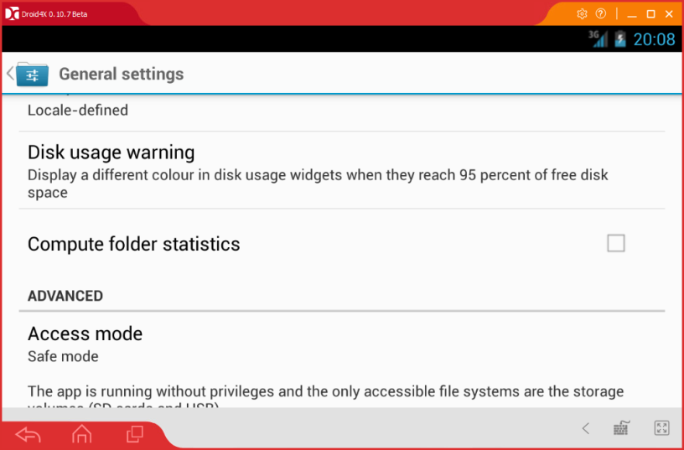

Select **Root Access mode** from the options available:

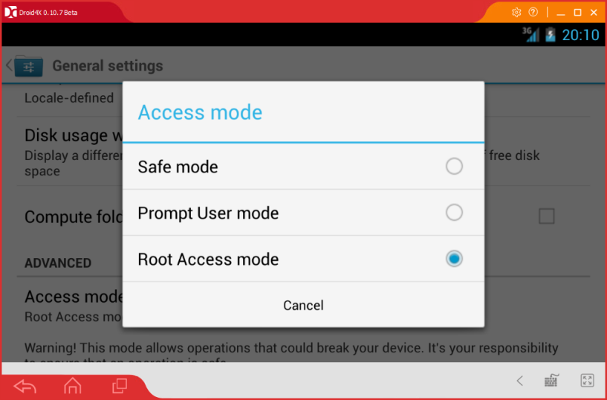

***Close the emulator and re-open for the settings to take effect***

With the emulator open, click on the settings button in the top right:

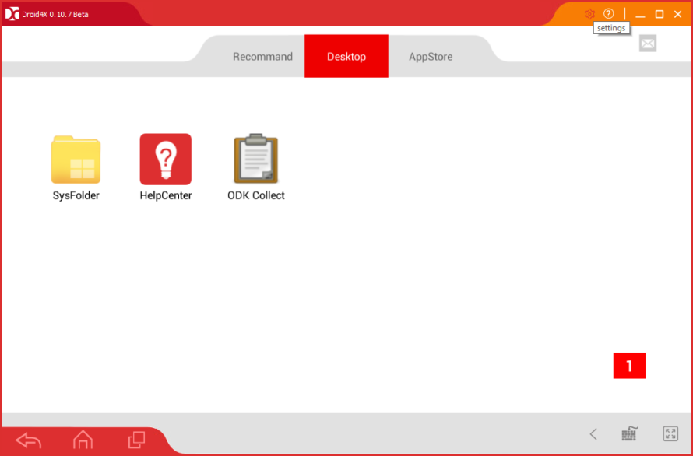

Click on Other Setting – Share Folder

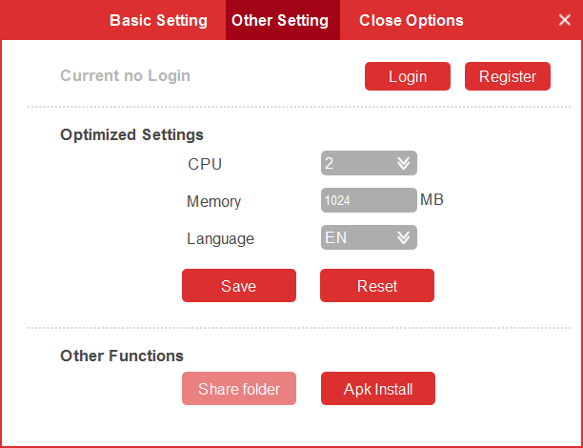

Select the folder where you have stored your form file (Desktop in this example), and click **OK.**

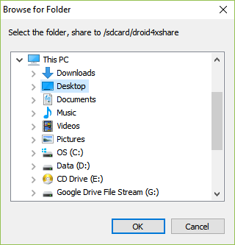

File Manager will open and show you the files on your desktop. Locate the form file (Philippines_v9.xml in this example) and select the checkbox next to the filename.

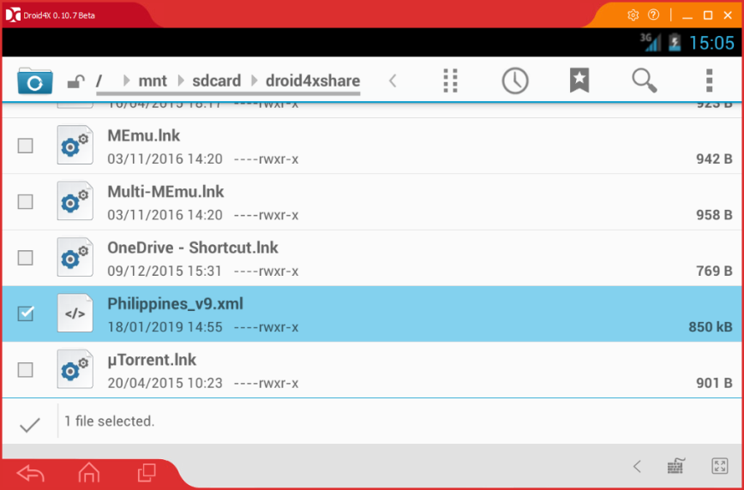

Once selected, click **sdcard** at the top, scroll down and click on the **odk** folder

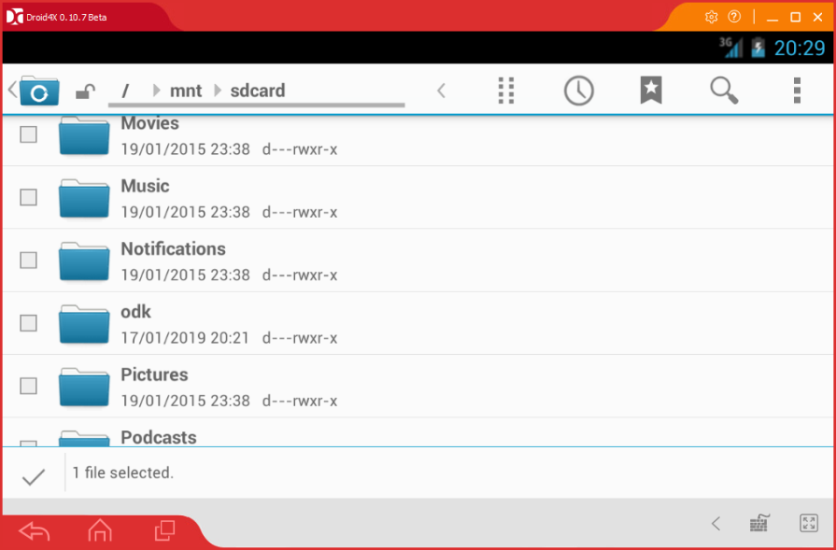

Select the **forms** folder

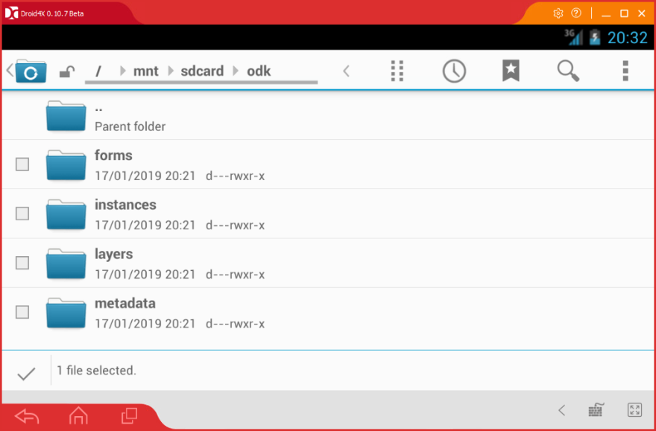

Click the eight-dots button at the top.

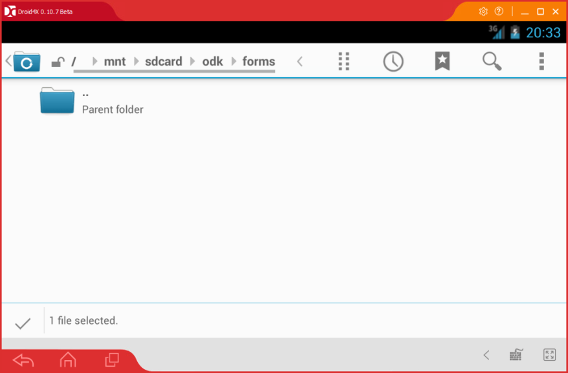

Click **Copy selection here**.

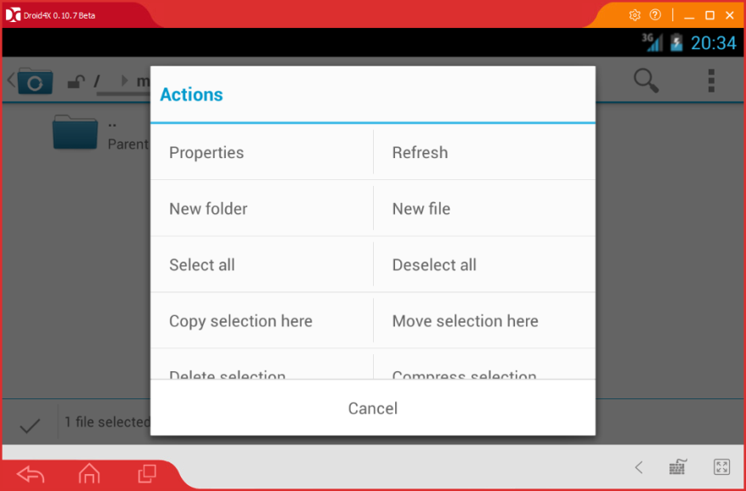

The file should now appear in the folder and you can return to the home screen:

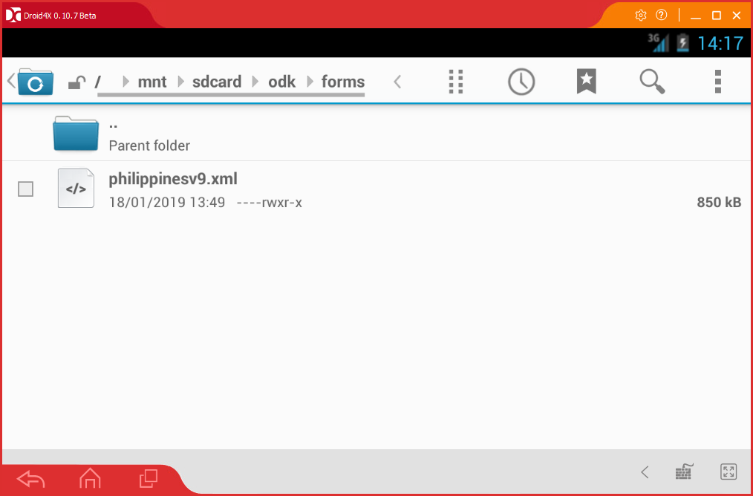

Launch ODK Collect and select Fill blank form. This will load the new form you have copied.

***Note: You may have to go back to the main ODK Collect screen and select Fill Blank Form again for it to appear.***

## Tablet Configuration

### Developer Mode

All Android devices running version 4.x and above will need to be configured to turn on Developer Mode to allow the program to access the ODK Files on the tablet via USB cable.

***Note: Unplug your tablet from the PC BEFORE you enable these settings and ensure you have restarted your PC.***

Each tablet will have slightly different methods to achieve this, but most of the newer devices will have a **Developer Options** area in the **Settings** of the device.

Go into ***Settings->Developer Options*** and ensure that Developer Mode is turned on, and that USB Debugging is also enabled.

The below is an example from a Samsung Tablet.

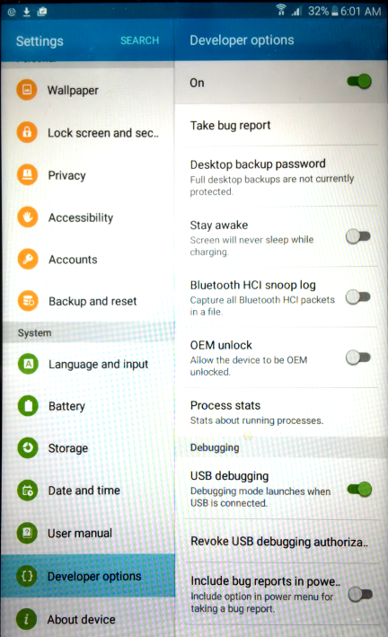

Once you have enabled this, plug the device into your PC/Laptop with the USB Cable. You should be prompted to allow USB debugging from your PC.

Select **‘Always allow this computer’** and press **OK.**

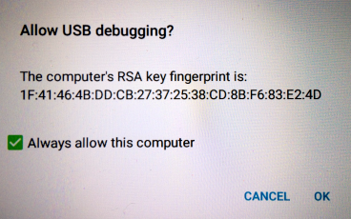

Your tablet is now connected and ready to run the program. These steps are only required once and in future you can simply connect the device and run the program as normal.

If you are unable to locate the Developer Options on your device, another common method is the following:

* Open Settings > About > Software Information > More.
* Tap “Build number” seven times to enable Developer options. ...
* Go back to Settings menu and now you'll be able to see “Developer options” there.
* Tap it and turn on USB Debugging from the menu on the next screen.

## Running for the first time – USB connected device

Once you have updated the configuration file to reflect the required settings for your implementation, and set the device to Developer Mode, you are ready to run the script for the first time.

With your device connected via USB, start the program from the icon on your desktop.

If presented with the screen below, press ‘**A**’ and then ‘**Enter**’ to continue. This will only be required the first time in most cases, to set the correct security settings on your computer to allow the program to run.

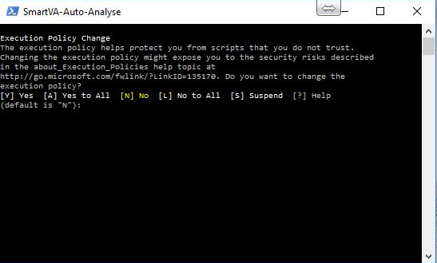

## Program Outputs – What does it do

### Screen Output

Assuming the configuration settings are correctly in place, once the program has begun, a progress bar will be updated to keep you informed of processing progress.

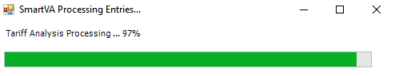

Upon completion, if you have chosen to display results (as set in the config.txt file) you will see a window displayed which will contain the first VA entry found on the tablet or Aggregate:

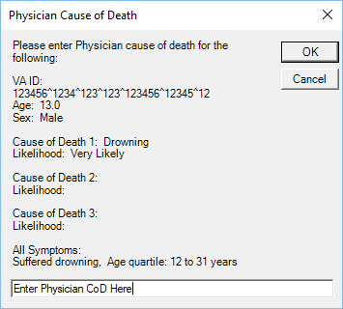

In the text box available at the bottom of the window, enter the Physician Cause of Death and Click **OK.** This process will be repeated for additional VA’s processed from the tablet or Aggregate Server until there are no more VA’s to process.

If you have chosen not to display results, then a confirmation box will show to advise how many records were processed and added to the results.csv file in the archive.

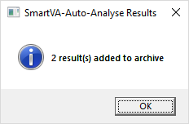

### File Outputs

#### Archive Folder

The archive folder is a location that is used to store two key pieces of information:

1. Copy of raw data from tablet once successfully processed
2. Results.csv file

***Note: A copy of the raw data will not be copied if using an Aggregate server. It is assumed that the server infrastructure will be backed up in accordance with best practices by the owners/managers of the server.***

Once the program has completed successfully, the underlying raw data for each result is copied to the archive, so that it can be used to perform future analysis as required (using the manual analysis method).

The archive folder location can be specified via the config.txt file (see Settings section for further information).

It should be noted that only data that has processed successfully will be copied to this archive, and therefore any errors in processing should be resolved to the point of successful program completion before any data is removed from the Tablet/Device.

#### Results.csv file

In addition to the output to screen, the program also outputs the results to a file called **results.csv**. This file is located in the **Archive** folder, which can be found as a sub-folder of the location set in the config.txt file under ArchiveDir (see Settings information above for more information about locations).

For example, the default location for archiving, as configured in the config.txt file, is **C:\SmartVA**.

If you navigate to this folder, you will see a sub-folder called **Archive**, and within that folder is the file **results.csv**.

This file is useful if you need to review the results of previous analysis performed, or if you have closed the screen output and wish to review the results again. The screenshots below show the file in the default location, and what its contents look like when opened in excel.

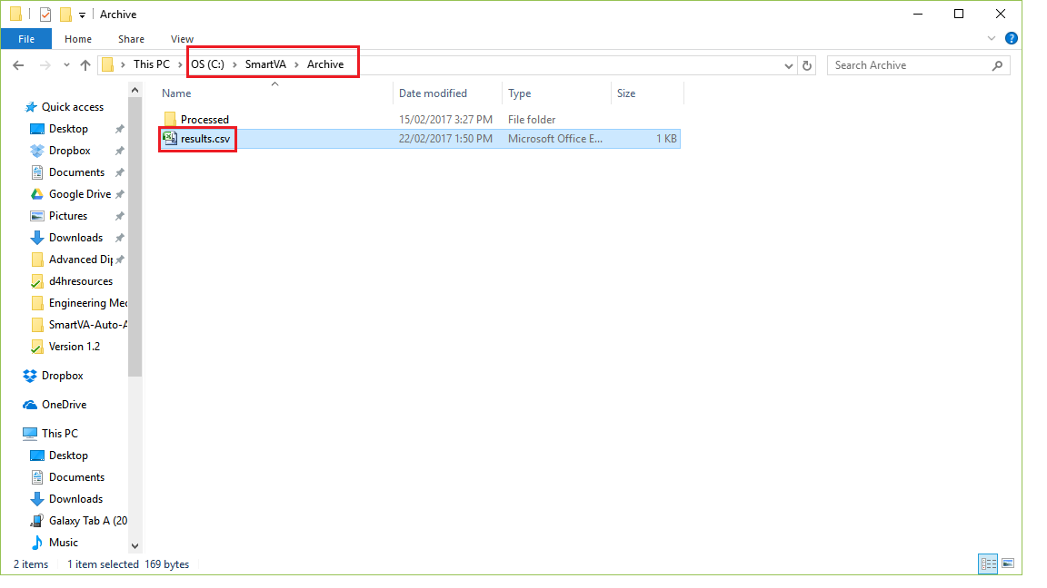

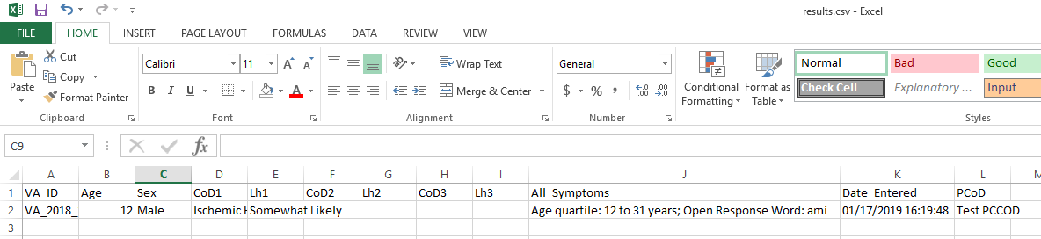

#### Log Files

When the program runs, all of the component parts (file copy from tablet, ODK Briefcase conversion & Tariff output) generate log files that can be reviewed if issues should arise. The **Logs** folder, contained within the **ProcessDir**, contains the following:

##### log.txt

This is the program log file and contains entries as each stage of the program runs/completes. Any error messages that are displayed to screen are also written to this file to aid with trouble-shooting. This log file should be checked first in case of any issues experienced.

##### adblog.txt

This log file contains information specific to the file copy from the tablet and can be used to further troubleshoot issues at this stage of the program run.

##### BriefcaseOutput.txt

This log file contains information specific to the ODK Briefcase conversion process and any issues with this stage of the program run will be logged here.

##### TariffOutput.txt

This log file contains the specific information relating to the Tariff analysis stage of the program run. Any issues experienced with Tariff analysis will be logged here.